Leprosy Disease
- What kind of disease does he have?

- How long ago did he get the disease?

- What is his name?

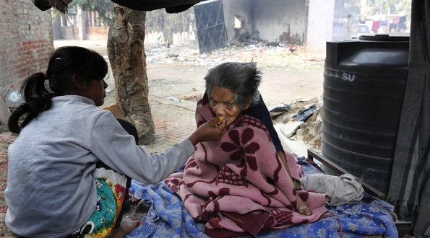
- What type of disease is it?

- Does the disease spread?

- Is it contagious?

- Where did he live after he had the disease?

- Do they lose everything or not?

- How many people live in Kasturba Gram?

- Is this disease dangerous?

- What year was when 10 million people were diseased?

- Can they defeat the disease?

